





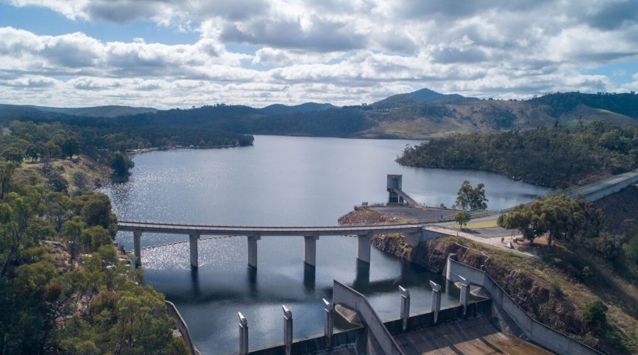




Lake Lyell Pumped Hydro

What we heard
October – November 2025

Targeted community consultation
EnergyAustralia and EDF power solutions Australia are progressing development of a pumped hydro energy storage project on land and waterways we own near Lithgow. An Environmental Impact Statement (EIS) is being prepared to meet NSW Planning Secretary’s Environmental Assessment Requirements. During October and November 2025, we delivered an intensive six-week engagement program to support the EIS for the Project. This engagement wave built on several years of ongoing conversations with the Lithgow community, neighbours, Council and government stakeholders.

10
Pop-ups
335
People spoken to
28
Print ads
9
Social media posts (reach)

112
Dot board participation
260
Radio ads
151
Feedback cards completed
15
Stakeholder briefings

Why we did it
We undertook this concentrated engagement period to to help inform the EIS and improve project outcomes.

How and who we spoke to

During this targeted community consultation, we provided a range of opportunities for the community to speak with us about the Project, and importantly, provide us with feedback on the Project.








Date & Venue/Activity Description Key metrics

1 Oct – 6 Nov 2025
Project HQ (Main St)

1 Oct 2025
Portland Family Fun Day

17 Oct 2025
Wallerawang Sports & Community Club
19 Oct 2025
Gone Fishing NSW Day- Lake Wallace
24 Oct 2025
Lithgow Valley Plaza

25 Oct 2025
Lithgow Halloween Street Party
26 Oct 2025
Lithgow Monthly Markets – Queen Elizabeth Park
27 Oct 2025
Lithgow Library

6 Nov 2025
Gang Gang Farmers Markets
Extended hours, including being open on Saturday, to be open and available to the community

An event attracting families with young children

Set up in the community club to speak with patrons. Our visitors were local workers and residents

Recreational users of local lakes and waterways

Set up near Coles, we spoke with senior residents of Lithgow, along with some tourists, and families who had attended a book fair at
St Patrick’s School

A community event with a great cross-section of the community present

A monthly community market attracting families and environmentally aware community members

Set up in the library to speak with local residents

A weekly community market attracting families and environmentally aware community members
Number of visitors: 14
Number of feedback cards completed: 4
Number of visitors: 60+
Number of feedback cards completed: 2
Number of visitors: 7
Number of feedback cards completed: 7
Number of visitors: 11
Number of feedback cards completed: 9
Number of visitors: 63
Number of feedback cards completed: 46

Number of visitors: 85
Number of feedback cards completed: 51
Number of visitors: 21
Number of feedback cards completed: 10
Number of visitors: 3
Number of feedback cards completed: 3
Number of visitors: 26
Number of feedback cards completed: 20

What we heard

71%
of you knew about the Project

Biodiversity was most important to you, with a particular interest in local platypus
65%
of you supported the Project

Lake Lyell is important to the community, especially for recreation

Biodiversity
Biodiversity was consistently mentioned over the period of engagement with protecting the local platypus population being of considerable importance. The community also emphasised the importance of protecting the natural environment, and wanting more information on how we plan to manage environmental risks.

Protect the platypus
This was the most discussed topic of engagement with people stressing the importance of platypus management plan, including relocation strategies and continuous monitoring.

Protect the natural environment
There is interest in how environmental offsets would be managed, monitored and how they operate.

Protect wildlife
Outside of protecting the platypus population, concerns extended to other local wildlife, including kangaroos, wombats, fish and birds, along with their habitat.

Keep the lake and waterways healthy
People were concerned about the potential impacts to the temperature of the lake, changes to the aquatic ecosystem, and water level management, especially during drought.


Recreational use
We acknowledge that Lake Lyell is important to the community, and visitors to the community, especially for recreation. People were most concerned about whether the lake would remain open to the public during construction and if they could continue fishing.

Keep the lake open
People want to retain access around Lake Lyell for various leisure pursuits. There were also concerns about limitations to fishing, particularly at Farmers Creek.

Access restrictions
Access should be maintained for leisure activities such as camping, skiing and 4-wheel driving, including the tracks around Mount Walker.



Ensure local fish stocks
The community would like fish stocks to be maintained at the lake with monitoring to occur to make sure fish food sources are not impacted by construction activities.

Opportunities for enhancement
The community would like to see improvements to existing recreational facilities, including jetties, picnic areas and walking trails.

Economic Impacts
The people we spoke with were interested in how the Project would support local jobs and help to revitalize the Lithgow Community. There were concerns over the cost of the project and potential increase to household energy bills.

Local employment
The expectation is for local jobs to be the priority, with a focus on apprenticeships and hiring current residents.

Value
There were concerns over the value of the Project and how expensive it is compared to implementing other energy sources.

Local economy
Feedback is that the Project has a role in revitalising the Lithgow economy and should favour local workforce and business participation.

Energy costs
While some people were optimistic that the Project may lead to a reduction in energy prices for households, others were concerned that the cost of the Project could increase energy prices.

Visual Impacts
Visual impact remains a prominent concern for community members with questions raised around altering the landscape and its long-lasting impacts on recreation and tourism.

Landscape alterations
Concerns that the upper reservoir will be an unwanted view from some areas and will detract from the natural landscape.

Tourism
People were concerned that any visual changes could negatively impact visitor numbers to Lake Lyell for camping and recreational activities.

Impacts to local business
There were concerns that the visual impact would deter visitors to the local businesses operating close to Lake Lyell.

Mitigation is needed
Some community members believed that the upper reservoir could blend into the natural environment with the right mitigation measures and made suggestions such as adding local artwork to the structure.

Community Benefits
The community expressed a clear desire for the Project to deliver a wide array of community benefits and contribute positively to the local area.

Economic stimulus
There is strong support for generating local employment opportunities, particularly for the younger generations, along with supporting local businesses.

Social initiatives
People want to see the Project support social initiatives with interesting suggestions such as improvement to First Nations housing and Projects to benefit local youths.

Other

Near neighbours
The community expects that near neighbours will receive a direct benefit from the Project.

Town improvements
The community believes the Project should benefit the entire town through initiatives such as revitalising the town centre, and to improve local infrastructure such as roads.

The community discussed many topics with the Project team and were highly engaged and interested in learning more about the Project.

Workers Accommodation
The community expressed a preference for in-town accommodation with a view that any housing should become a social legacy, such as future affordable housing.

Energy Transition
There was strong support for “clean energy” and for pumped hydro, with many residents preferring it over wind and solar due to factors such as visual impact, operational lifespan and reliability.

Traffic and roads
People expressed concern for the anticipated increase in traffic and the adequacy of the existing road network. There were also concerns about any interruption to people accessing their homes.

Location suitability
Some community members supported the concept of pumped hydro but not the location.

Quick and engaging
While we love to chat, some feedback needs to be taken as quickly as possible so that you can get on with your day.
Enter the Lake Lyell Pumped Hydro Dot Board. A quick and effective way to get feedback from people who didn’t have time to stop and chat. We used the board to ask if you had heard of the Project, whether you supported the Project or not, and what topics you wanted to know more about or were concerned about.
























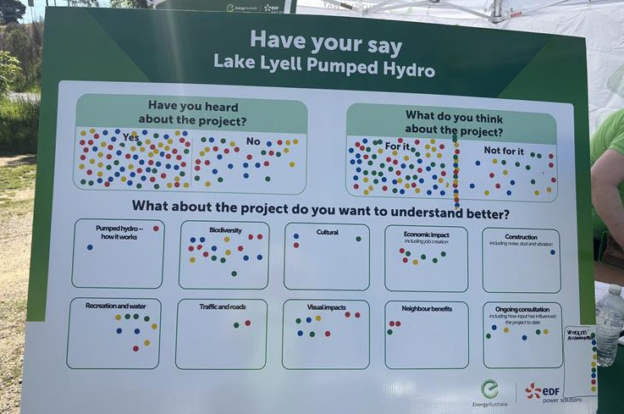
In total, 112 of you participated
65%
19%
What is important to you
Here’s what you wanted to talk about in order of importance.
1
2
3
Biodiversity
Recreation & water
Workers accommodation
4
5
Visual impacts
Economic impacts
6
Ongoing consultation
7
Neighbour benefits
8
9
10
Cultural
Traffic & roads
How pumped hydro works
11
Construction
Next steps
16%

The next phase of the Lake Lyell Pumped Hydro Project is the submission of the EIS which we anticipate will occur in early 2026.
The EIS will be on public exhibition for a minimum of 28 days and is open to submissions from the community. We’ll be sure to keep you updated when the EIS goes on public exhibition.
In the meantime, Project HQ will remain open, and we encourage the community to visit us there to ask questions and receive Project updates.
Thank you to all community members who have given their feedback to date. We respect all opinions and are grateful for your valuable insights and active participation.





We look forward to continuing to speak with you throughout all phases of the Project.
Have your say
If you missed us at these events, or simply have more to share, we would love to hear from you. Email: Community@energyaustralia.com.au
Phone: 1800 574 947
In person: Project HQ, 124 Main Street, Lithgow
For more information:
W lakelyellpumpedhydro.com.au
Get social with us: Lithgow Light the Way

