

Lake Lyell Pumped Hydro

Workers’ accommodation

Acknowledgement
EnergyAustralia and EDF power solutions Australia acknowledge that the site of the proposed Lake Lyell Pumped Hydro project is on the traditional Country of the Wiradjuri People. We recognise their continued connection to land, waterways and community, and we pay our respects to Elders past and present.
Contents
About the Environmental Impact Statement 2
What is workers’ accommodation? 2
Preferred site — Lakeside camp option 3
Alternative site — Town camp option 4
Have your say on the workers accommodation facility 5
How we will use your feedback 5
Engage with us 5
Learn more 6
Get in touch 6

About the Environmental Impact Statement
We are progressing development of a pumped hydro energy storage project on land and waterways we own near Lithgow. An Environmental Impact Statement (EIS) is being prepared to meet NSW Planning Secretary’s Environmental Assessment Requirements. The EIS includes multiple technical studies such as the Social Impact Assessment and the Economic Impact Assessment which refer to workers’ accommodation. These have been summarised here.

What is workers’ accommodation?
The Project will require a workforce of approximately 600 workers during the five-year construction phase, with 70 per cent expected to be sourced from outside the region.
Temporary workforce accommodation that can house up to 500 workers is proposed as part of this project.
Workers requiring accommodation for a short period can secure local accommodation, providing a boost to local motels or short-term rental suppliers. However, where accommodation is needed for a large workforce for several years, using motels or local rentals could place pressure on the local housing market and increase rental costs for the whole community.
We have undertaken extensive engagement with the local community to ensure that the planning process is inclusive and responsive to public feedback. As part of that process, two site options for workers accommodation are being considered.
In site selection, we look at proximity to the worksite or the central business district, safety and security, nearby infrastructure and amenities or the need to build utilities, accommodation quality, cost, sustainability and proximity to neighbours.


Preferred site — Lakeside camp option
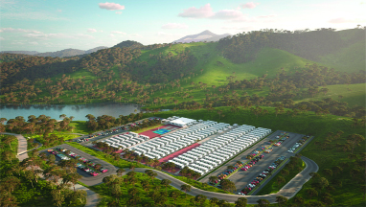
The preferred site for workers’ accommodation is alongside Lake Lyell off Magpie Hollow Road, South Bowenfels (known as the lakeside camp option).
The preferred proposed site for workers’ accommodation is alongside Lake Lyell off Magpie Hollow Road, South Bowenfels (known as the lakeside camp option). We own this land and lease it to Lithgow City Council.
The key benefits of this location include:
 Proximity to the worksite
 Contained, ensuring safety and security
 Reduced traffic impact on local roads and the Great Western Highway
 Minimises number of near neighbours impacted
 Potential uses post construction
 Accessible to Lake Lyell for recreation and worker wellbeing

Alternative site — Town camp option
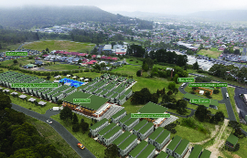
Alternative workers accommodation site on the former Pottery Estate off Silcock Street (known as the town camp option).
The proposed alternative site is in town on the former Pottery Estate off Silcock Street (known as the town camp option). It is privately owned, and we would need to enter an agreement to construct and operate a facility at the site.
The key benefits of this location include:
 Proximity to local businesses for economic benefit
 Close to existing infrastructure and amenities
 Contained, ensuring safety and security
 Potential uses post construction
 Opportunity to protect and enhance local heritage
The final site selection will be informed by environmental assessments, logistical considerations, and the outcomes of community consultation.
The facility is expected to be completed early in the construction phase and will be in operation for the duration of the Project’s construction.
Once construction has finished, we’ll explore ways to retain or repurpose the workers’ accommodation as a community asset should that be in the community’s interest.

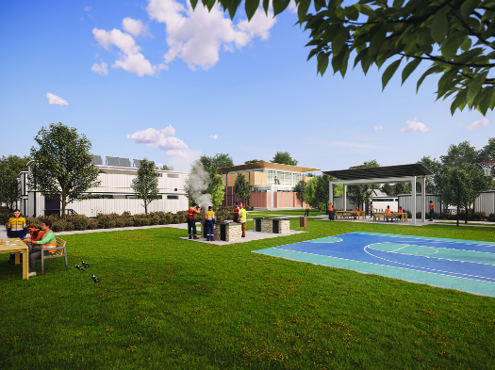
Artist’s impression of workers’ accommodation.

Have your say on the workers accommodation facility
We will continue to engage with the community and neighbours, so that either worker accommodation site can be designed and operated in a way that minimises impacts to those nearby.
- provide feedback on options for workers’ accommodation during community consultations or public comment periods
- engage with project representatives or community committees to discuss concerns and suggestions

How we will use your feedback
Any feedback you provide before the Environmental Impact Statement is submitted will be recorded and, where appropriate, used to help refine the assessment and improve project outcomes.

Engage with us
There are many ways to have your say during the targeted community consultation running from 15 Oct to 30 Nov 2025 — online, in person, by phone or email. Find out more at:
lakelyellpumpedhydro.com.au


Consultation purposes only: This document is provided for community consultation purposes and the information it contains may be updated or revised in the final Environmental Impact Statement.

Learn more


Get in touch
E community@EnergyAustralia.com.au
P 1800 574 947
A EnergyAustralia Project HQ,
124 Main St, Lithgow
W lakelyellpumpedhydro.com.au

Proudly funded by

Public acknowledgement and disclaimer. This project is proudly funded by the NSW Government’s Pumped Hydro Recoverable Grants Program. The views expressed are not necessarily the views of the NSW Government. The NSW Government does not accept responsibility for any information or advice provided.

