

Lake Lyell Pumped Hydro

What we have heard to date

Acknowledgement
EnergyAustralia and EDF power solutions Australia acknowledge that the site of the proposed Lake Lyell Pumped Hydro project is on the traditional Country of the Wiradjuri People. We recognise their continued connection to land, waterways and community, and we pay our respects to Elders past and present.
Contents
About the Environmental Impact Statement 2
Why is it important? 2
We have been listening since 2021, and continue to listen 3
Who we have heard from 4
What we heard to date — key project areas 4
How we are using this feedback 10
Have your say on what we have heard 11
How we will use your feedback 11
Engage with us 11
Learn more 12
Get in touch 12

About the Environmental Impact Statement
We are progressing development of a pumped hydro energy storage project on land and waterways we own near Lithgow. An Environmental Impact Statement (EIS) is being prepared to meet NSW Planning Secretary’s Environmental Assessment Requirements (SEARs), including a Consultation Report which summarises what has been heard throughout the engagement period.
Here we provide a high-level summary of the feedback, ideas and concerns shared by the community and neighbours during engagement and consultation activities.
This summary:
- outlines what people said during meetings, surveys, and other engagement
- helps decision-makers understand what matters most to the community
- shows transparency by making it clear how feedback is being considered
- builds trust by keeping the community informed

Why is it important?
It’s one of the key ways we show that we’re not just asking for feedback — we’re listening.
- gives everyone a chance to see what others are saying
- shows how community views are shaping decisions
- makes the consultation process open and accountable
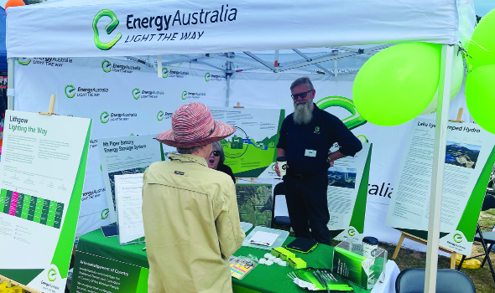
Receiving feedback at the Rydal Show February 2025.

We have been listening since 2021, and continue to listen
Year | Engagement Activities
2021 | Initial Community Town-hall Meeting
2022 | Wave 1 — Pop-up engagements at local community events and locations
2022 | Project website and newsletter launched
2023 | Wave 2 — Pop up engagements at local community events and locations
2023 | Initial upper reservoir design for community feedback  Upper reservoir design changed in response to community feedback  Neighbour engagement begins  Community participation in ecological studies  Project HQ opens  Virtual community and industry townhall Meeting  Concept design released
2023 | Wave 3 — Pop up engagements at local community events and locations
2024 | Wave 4 — Pop up engagements at local community events and locations
2024 | Ongoing community and neighbour engagement  Recognised Aboriginal Parties involved in Aboriginal Cultural Heritage Assessment  Artefacts temporarily entrusted to archaeologist for analysis  Co-design workshops held to develop the Shared Benefit Program  Release of the initial Neighbour Benefit Guide for feedback
2025 | Wave 5 — Pop up engagements at local community events and locations
2025 | Ongoing community and neighbour engagement  Release of final Neighbour Agreement Guide  Release of draft Shared Benefit Program Report for feedback  Recognised Aboriginal Parties welcome the return of artefacts to Wiradjuri Country  Neighbour agreement for eligible neighbours process begins
From 2021 to 2025, we’ve been actively listening to the community through a wide range of engagement activities as well as through community channels, media commentary, meetings and discussions where the project has arisen.
Over this time, we’ve reached an estimated 170,000 people through in-person events, webinars, town halls, council meetings, visits to Project HQ, and digital channels like social media, video content, and our website.
This broad engagement has helped us hear a diverse range of voices, understand local priorities, and ensure community feedback is informing the project every step of the way.

Who we have heard from
We have been listening to local knowledge, advice and feedback from:
- Traditional Owners — cultural knowledge, heritage, oversight
- Lithgow City Council — planning, design, regulation
- government departments/regulators — environmental, planning, compliance
- community groups — broader community perspectives
- local residents — general public input
- Community Consultative Committee (CCC) — ongoing stakeholder feedback
- directly impacted neighbours — individual engagement, mitigation concerns

What we heard to date — key project areas

 Consultation and engagement
We have carefully listened to feedback about the engagement process and adjusted to improve transparency and accessibility. By responding to concerns about timing and information clarity, we’ve worked to ensure all voices are heard and those most impacted receive the support they need throughout the project.

Acknowledging opposition
We respect anyone’s right to oppose the project, which is especially understandable for neighbours who may be more directly affected than others in the community.

Providing more detail, when its ready
There’s strong interest from the community in the detailed information about potential impacts and mitigation measures, and people have shown patience while the technical and environmental studies — where this detail is developed — have been underway.

Statutory public exhibition period
There’s concern that the minimum 28-day EIS exhibition period is too short given the complexity and amount of detail in the project.

Taking care of people most impacted
People want to understand what support will be provided to those most affected by the project.

Accessible face to face opportunities
We’ve heard that people lead busy lives and appreciate the chance to connect with us at community events or by dropping into the Project HQ to learn more and share their thoughts.

Value information sharing
The community values ongoing, transparent communication to build trust and ensure all voices are considered throughout the project.

 Community benefits
Throughout all engagement activities, you have clearly indicated a desire to see a wide range of community benefits and social legacy outcomes from the project and the revenue sharing arrangements. Five key themes emerged by early 2024 which were explored in co-design workshops that shaped the draft Shared Benefit Program released in early 2025. Additional feedback was received about the proposed initiatives and when the shared funding would be available.

Better visitor infrastructure and wayfinding
People are keen to see new facilities in Lithgow and clearer signs that attract events, tourists, and enhance the visitor experience.

Protect the natural environment
There’s strong support for grant programs that fund environmental projects and ongoing efforts to care for biodiversity and water quality.

Create more skills, training, and education opportunities
The community wants workforce readiness programs, scholarships, and investments in education and innovation.

Improve local services and infrastructure
Many have suggested repurposing the workers’ accommodation village to provide more services and activities for young people, plus grants to support local events.

Partner with First Nations
People want to see stronger cultural understanding, care for the environment and opportunities for immersion, like a cultural centre within the local government area.

Increase shared revenue and bring it forward
There’s a clear call for shared revenue to be available during construction and for it to start in the early years of operation.

 Cultural heritage
In accordance with the Heritage NSW Code of Practice, we have respectfully engaged with 21 Registered Aboriginal Parties (RAPs). The RAPs included locally based Wiradjuri Traditional Owners, the local Aboriginal Land Council, and several regionally based individuals and organisations with Wiradjuri heritage, a strong personal connection to country in the Lithgow area in cultural heritage management.
Since the beginning of technical and environmental studies in 2023, RAPs have played an active and valued role in investigating, assessing, and managing cultural heritage associated with the Lake Lyell Pumped Hydro Project. Their knowledge, guidance and leadership continue to help shape how cultural values are recognised, respected and protected throughout the project.

Protect our cultural health and wellbeing
It’s vital the project supports both the spiritual and physical connection First Nations people have to Country.

Care for Country properly
People want to see land, water, and biodiversity looked after in a way that respects Aboriginal custodianship.

Improve cultural understanding
There’s a strong call for genuine engagement, education, and making sure Aboriginal perspectives are truly included in decisions.

Respect sacred sites and cultural landscapes
We’ve heard how important it is to identify, protect, and avoid disturbing places of cultural significance.

Handle artefacts with respect
The community wants cultural materials to be carefully managed, stored securely, or returned where appropriate.

Long term protection
People want measures that help ensure cultural heritage is looked after well beyond the life of the project.

 Jobs and economic activity
Economic impact has been a consistent and important discussion point throughout engagement, particularly with local businesses and industry groups. From the early stages of planning, stakeholders have expressed strong interest in how the project can help support local jobs, create opportunities for small and medium enterprises, and contribute to long-term economic growth in the region.

Local jobs first
People want to see local workers and businesses given priority throughout construction and operation.

Support youth training and apprenticeships
There’s a real push to create pathways for young people to learn skills and find steady, long-term jobs without having to leave the local area.

Encourage new technology and innovation
Folks are excited about opportunities to bring in new renewable energy industries and support regional innovation.

Boost the local economy during construction
Many have highlighted how important it is for local services, suppliers, and accommodation providers to benefit while the project is being built.

Create jobs and growth that last
People want stable employment and ongoing investment that extends well beyond just the construction phase.

Help us build skills and knowledge locally
There’s strong support for training programs and knowledge-sharing that improve local workforce capabilities over time.

 Environment
Throughout engagement, we’ve consistently heard that protecting the local environment is a top priority for the community, stakeholders, and experts. People have emphasised the importance of carefully managing the project’s environmental footprint, with a strong focus on avoiding or helping to minimise impacts, creating meaningful and lasting offsets, and maintaining the health of ecosystems connected to Lake Lyell and surrounding areas.

Keep the lake and waterways clean and healthy
People want to make sure water quality is protected so the lake and connected rivers stay safe for wildlife and people.

Protect our native plants and animals
There’s a strong desire to avoid and minimise habitat loss and help local species recover and thrive.

Look after platypus and fish
Many have stressed the importance of special measures to protect sensitive species like the platypus and local fish.

Make environmental offsets meaningful
People want offset programs that restore or improve the natural environment, not just tick a box.

Stop erosion and sediment problems
People are concerned about soil and waterway damage, especially during construction, and want strong controls in place.

Keep watching and caring long-term
The community expects ongoing monitoring and management to protect the environment well beyond when the project finishes.

 Roads and traffic
Roads and traffic management have been a consistent focus of community and stakeholder feedback, especially in relation to construction impacts and long-term safety. We’ve heard the importance of upgrading local roads, managing truck movements responsibly, and ensuring that road improvements leave a lasting benefit for the community. Supporting safe travel — particularly for and inexperienced drivers — has also been a strong theme.

We want better, wider roads
Many people want the roads improved beyond just single lanes to make travel safer and easier for everyone.

Manage truck movements carefully
People are concerned about heavy vehicles and want clear plans to reduce risks by controlling routes, timing, and speeds.

Support for local councils to maintain roads
It’s important that councils get the resources they need to keep roads in good shape during and after construction.

Make roads safer for everyone
Locals want road upgrades that take into account pedestrians, cyclists, and all kinds of drivers.

Keep young and learner drivers safe
There’s real concern about road safety for younger people, and requests for extra measures to improve their safety.

Minimise disruption while work’s happening
The community expects to be kept informed and for traffic changes to be managed so construction doesn’t cause too much inconvenience.

 Recreational use
Recreational use of Lake Lyell has been a key area of community interest and feedback. People have told us they value the lake for activities like boating, water skiing, fishing, and kayaking, and want to see continued public access and safe use during both construction and operation of the pumped hydro project. We’ve also heard that many visitors and residents were not previously aware that Lake Lyell is an operational energy asset, and there’s strong interest in clear communication around how water levels will change and what this means for recreation.

Keep the lake accessible during construction and operation
People want to be able to keep enjoying the lake safely, without too much disruption while work on the Project is happening.

Upgrade and add facilities
There’s a clear call for better boat ramps, jetties, and access paths so we can reach the water even when levels change.

Give us predictable water level info
Locals and visitors want regular, clear updates about when the lake will be lowered or raised so they can plan their activities.

Support fish restocking
Many fishers want to see ongoing efforts to replenish fish stocks, so the lake stays great for fishing.

Be clear about the lake’s energy role
People want to understand that the lake is both for recreation and energy, and they appreciate honest communication about this balance.

Make safety a priority with signage and info
We’ve heard that good signs and clear communication are important to keep everyone safe, especially as water levels and conditions change.

 Project design and viewpoints
Project design and visual impact have been central to community feedback, especially for those living near or visiting the Lake Lyell area. In 2023, the initial concept design placed the upper reservoir facing the town of Lithgow. After hearing concerns about how this would affect scenic views and the character of the surrounding mountains, the design was significantly revised. People have told us they want infrastructure that respects the landscape, considers how it looks during and after construction, and preserves the visual appeal of the area.

Minimising impact on Mt Walker
People want the natural views of the mountains, especially from around Lithgow, to be protected as much as possible.

Preserving iconic vantage points
Locals and visitors alike have said it’s important to preserve the views from popular spots around Lake Lyell.

Managing construction‑phase visual impacts
There’s a strong interest in understanding what the site will look like before and after vegetation has regrown, and how long that will take.

Using natural screening and vegetation
Many have suggested replanting native trees and shrubs to help screen infrastructure and return the area to a more natural look.

Designing infrastructure with the landscape in mind
We’ve heard that the look and feel of the project should respect the natural surroundings, using materials and colours that blend in.

Refining the design based on community feedback
People appreciated that the design changed after initial feedback, especially moving the upper reservoir away from the town’s main viewpoint.

 Voluntary neighbour agreements
Neighbours are important to us. We want to ensure eligible neighbours are provided with fair and reasonable supports to manage the changes presented by the project to their properties and livelihoods. Between July 2023 and March 2025, we engaged with a number of neighbours to develop the voluntary neighbour agreement program that includes meaningful financial offerings.

Resilience and readiness for change
Most neighbours we consulted expressed a need for support to adapt to changes from the proposed project and were open to the support payments outlined in Neighbour Benefits Guide for resilience and wellbeing.

Construction noise
Neighbours would like more information on noise impacts, with many sharing examples of noise in the area. They suggested various noise mitigation measures, including double glazing, noise-cancelling headphones, landscape screening, temporary walls, relocation, respite periods and adjusted construction timings.

Visual impacts
Neighbours discussed how the project would impact property viewpoints and suggested mitigation measures such as window reorientation, landscaping, and screening, tailored to each property.

Property value
Neighbours noted potential property value loss and suggested independent valuations before and after construction to assess impacts and inform compensation.

Business sustainability
Neighbouring businesses shared how they believed the project would affect their operations and considered sustainability or continuity payments, including timing and evidence of impact.

Clear guidance
Neighbours suggested renaming the Neighbour Benefit Guide to the Neighbour Agreement Guide and adding more details on the property valuation process. This change has been made.

 Workers accommodation
We have actively listened to the community’s feedback as we considered suitable and well-located workers accommodation to support the workforce needed for the Lake Lyell Pumped Hydro Project. Initially, the lakeside site at Magpie Hollow Road was proposed in 2024 as our preferred location, with the former Pottery Estate later identified in 2025 as an alternative option. Importantly, we have engaged closely with residents, the broader community, and key stakeholders to understand their concerns and priorities, helping to shape the design and operation of the accommodation to help minimise any adverse effects.

We want the site close to the town centre
It’s important for us that accommodation is near the Central Business District so workers can easily access local services and shops.

Concerns about noise
People want to know how noise from the accommodation will be managed to keep things peaceful for nearby residents.

Traffic needs to be carefully managed
There’s a lot of worry about the extra vehicles, especially around shift change times, and how that will affect local roads.

We want the site to blend in visually
People don’t want the accommodation to stand out or spoil the look of the area.

Think about what happens after construction
Many people want the accommodation to be designed so it can be used for other community needs once the project is done.

Be clear about utilities and worker behaviour
People want to know how water and energy will be used responsibly, and that workers will be respectful and well-managed.

How we are using this feedback
We listen to the community and stakeholders at every stage of the project. Your feedback helps shape key decisions — from design and construction methods to how we reduce impacts on the local area.
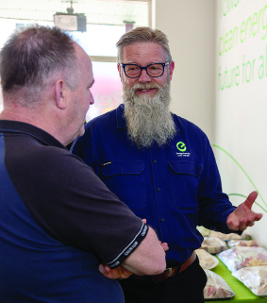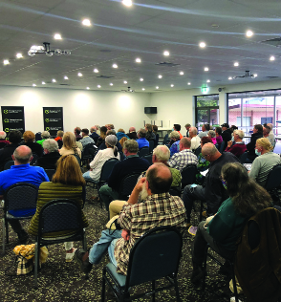
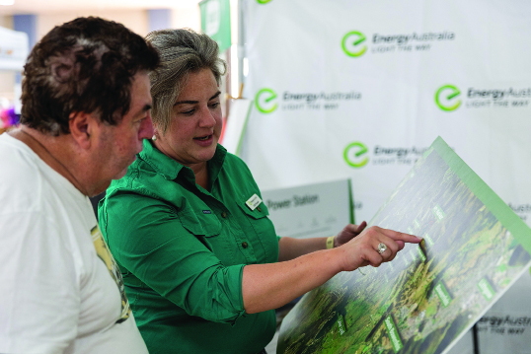
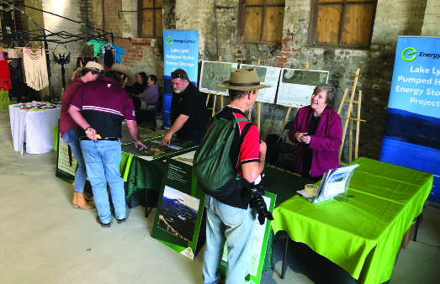
Community Engagement at Iron Fest in 2024.

Have your say on what we have heard
We encourage you to review the related information detailing the impacts and mitigation measures identified through our engagement process. Your feedback is valuable — whether you want to share additional thoughts, ask questions, or let us know where you agree with what has been heard so far. There are multiple ways to have your say, and we welcome your input to help shape the project as it progresses.

How we will use your feedback
Any feedback you provide before the Environmental Impact Statement is submitted will be recorded and, where appropriate, used to help refine the assessment and improve project outcomes.

Engage with us
There are many ways to have your say during the targeted community consultation running from 15 Oct to 30 Nov 2025 — online, in person, by phone or email. Find out more at:
lakelyellpumpedhydro.com.au


Consultation purposes only: This document is provided for community consultation purposes and the information it contains may be updated or revised in the final Environmental Impact Statement.

Learn more


Get in touch
E community@EnergyAustralia.com.au
P 1800 574 947
A EnergyAustralia Project HQ,
124 Main St, Lithgow
W lakelyellpumpedhydro.com.au

Proudly funded by
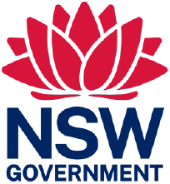
Public acknowledgement and disclaimer. This project is proudly funded by the NSW Government’s Pumped Hydro Recoverable Grants Program. The views expressed are not necessarily the views of the NSW Government. The NSW Government does not accept responsibility for any information or advice provided.

