

Lake Lyell Pumped Hydro

What is an Environmental Impact Statement?

Acknowledgement
EnergyAustralia and EDF power solutions Australia acknowledge that the site of the proposed Lake Lyell Pumped Hydro project is on the traditional Country of the Wiradjuri People. We recognise their continued connection to land, waterways and community, and we pay our respects to Elders past and present.
Contents
About the Environmental Impact Statement 2
What is the Environmental Impact Statement (EIS)? 2
Why is an EIS required for the Lake Lyell Pumped Hydro Project? 2
How the planning approval process works for the Project 4
How to have your say 4
Learn more 5
Get in touch 5

About the Environmental Impact Statement
We are progressing development of a pumped hydro energy storage project on land and waterways we own near Lithgow. An Environmental Impact Statement (EIS) is being prepared to meet the NSW Planning Secretary’s Environmental Assessment Requirements (SEARs).

What is the Environmental Impact Statement (EIS)?
The EIS is a document required for State significant infrastructure (SSI) projects under the NSW Environmental Planning and Assessment Act 1979. We have prepared an EIS for the Lake Lyell Pumped Hydro Project (the Project) outlining the following:
- details of a proposed project
- how the project will be built
- assessment of its potential economic, environmental, and social impacts
- mitigation measures to help reduce these impacts
The key goal of an EIS is to provide decision‑makers, communities, and stakeholders with sufficient information to understand project impacts, compare alternatives, and determine strategies to help avoid, minimise or offset any negative consequences.

Why is an EIS required for the Lake Lyell Pumped Hydro Project?
In June 2024, the NSW Minister for Planning and Public Spaces declared the project to be Critical State Significant Infrastructure (CSSI). The Project requires the preparation of an EIS for the project in accordance with the SEARs and the approval of the Minister.
The Project is deemed a ‘controlled action’ under the Environment Protection and Biodiversity Conservation Act 1999 and requires approval from the Australian Minister for the Environment. It will be assessed via the bilateral agreement between the Commonwealth of Australia and the State of New South Wales. In summary, this means that approval of the Project is required from both the NSW Minister for Planning and Public Spaces and the Australian Minister for Environment and Water.
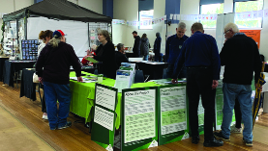
Community and stakeholder engagement over the last few years has helped us shape the Project’s EIS.
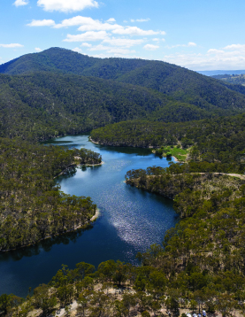
Mount Walker and the Farmers Creek arm of Lake Lyell (as well as other locations nearby) have hosted scientists, engineers and other experts undertaking investigations to develop the Project design and identify the impacts of the project which are detailed in the EIS.

How the planning approval process works for the Project
There are four main steps in the planning approval process for a Critical State Significant Infrastructure (CSSI) project like Lake Lyell Pumped Hydro Project:

1. Scoping Report and SEARs
The Project team submitted a scoping report to Department of Planning, Housing and Infrastructure (DPHI) in 2023 and received the project’s SEARs in July of that year. There have been two amendments to the project’s SEARs since then:
- The first was in June 2024 when the NSW Government declared the project CSSI.
- The second was in July 2025 when the partnership between EDF power solutions Australia and EnergyAustralia was announced.

2. Prepare EIS – (WE ARE HERE)
Since receiving the project’s SEARs in July 2023, scientists, engineers and independent experts have been developing the concept design and identifying the potential impacts of the project and mitigation measures for biodiversity, aquatic ecology, social impact, water, climate effects and more. Collectively, this information forms the EIS.
Community and stakeholder feedback over the last several years has also helped inform the development of the EIS and relevant technical studies.
Community consultation is an ongoing process. We will consult with all stakeholders during the preparation of the EIS and continue the consultation after it has been lodged with DPHI so as to inform the design, construction and operation of the project.

3. Public Exhibition
In the coming months, the EIS will be submitted to DPHI. The EIS will be publicly exhibited for at least 28 days, allowing the community and stakeholders to view it and make submissions.

4. Assessment and Determination
After public exhibition, and submissions are received, the project team will prepare a ‘response to submissions’ report, which outlines how the project has considered community and stakeholder feedback and made changes to the project where possible.
The NSW Minister for Planning and Public Spaces will then evaluate the merits of the project, paying attention to the economic, environmental, and social impacts, the issues raised during consultation and in submissions, and the principles of ecologically sustainable development.
After considering the project, the Minister will publish a notice setting out the decision and how community views were considered in making the decision.

How to have your say
There are many ways to have your say during the targeted community consultation running from 15 Oct to 30 Nov 2025 — online, in person, by phone or email. Find out more at:
lakelyellpumpedhydro.com.au


Consultation purposes only: This document is provided for community consultation purposes and the information it contains may be updated or revised in the final Environmental Impact Statement.

Learn more


Get in touch
E community@EnergyAustralia.com.au
P 1800 574 947
A EnergyAustralia Project HQ,
124 Main St, Lithgow
W lakelyellpumpedhydro.com.au

Proudly funded by
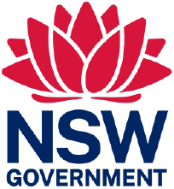
Public acknowledgement and disclaimer. This project is proudly funded by the NSW Government’s Pumped Hydro Recoverable Grants Program. The views expressed are not necessarily the views of the NSW Government. The NSW Government does not accept responsibility for any information or advice provided.

