

Lake Lyell Pumped Hydro

Traffic impact assessment

Acknowledgement
EnergyAustralia and EDF power solutions Australia acknowledge that the site of the proposed Lake Lyell Pumped Hydro project is on the traditional Country of the Wiradjuri People. We recognise their continued connection to land, waterways and community, and we pay our respects to Elders past and present.
Contents
About the Environmental Impact Statement 2
What is a traffic impact assessment? 2
How is a traffic impact assessment undertaken? 4
What are the impacts and mitigations? 4
Have your say on traffic and roads 4
How we will use your feedback 4
Engage with us 4
Learn more 5
Get in touch 5

About the Environmental Impact Statement
We are progressing development of a pumped hydro energy storage project on land and waterways we own near Lithgow. An Environmental Impact Statement (EIS) is being prepared to meet NSW Planning Secretary’s Environmental Assessment Requirements. The EIS includes multiple technical studies such as the Traffic Impact Assessment summarised here.

What is a traffic impact assessment?
It uses relevant studies and reports to assess traffic and road impacts of the Project during construction and operation, including traffic volumes, conditions and safety. It determines key traffic, safety and performance constraints along the Project’s key routes and intersections and recommends appropriate mitigation measures where required.
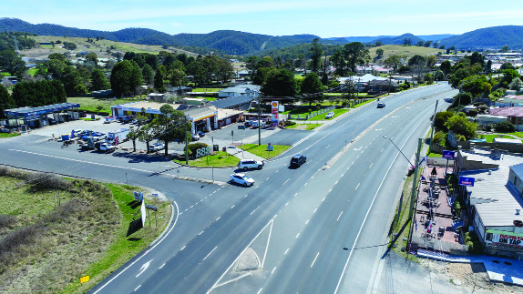

Proposed construction traffic routes
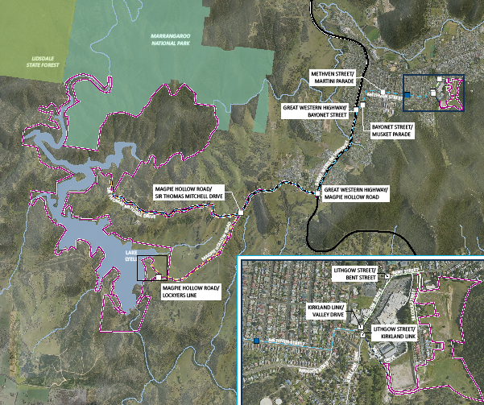
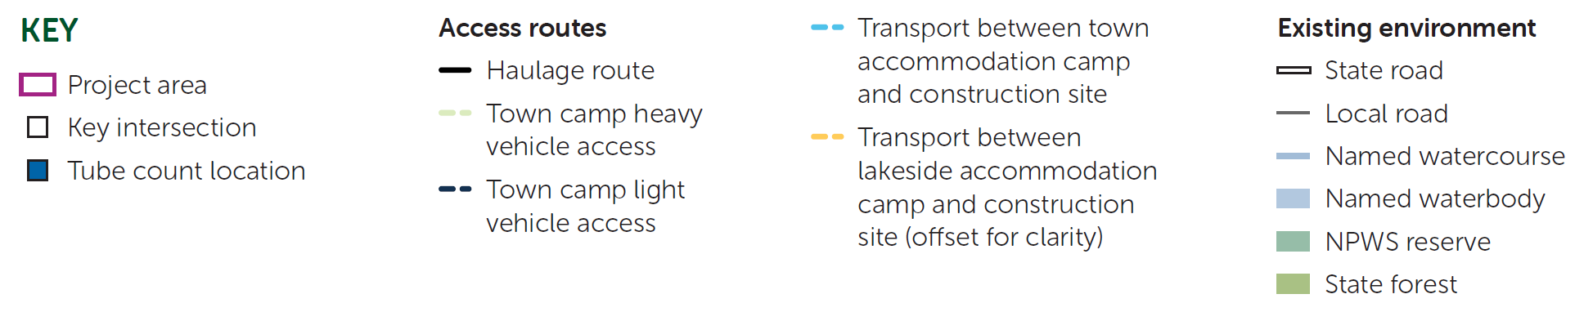

How is a traffic impact assessment undertaken?
The traffic impact assessment evaluates the Project’s impacts on the surrounding road network through examination of existing traffic volumes and capacity and the adequacy of key roads and intersections. It assesses estimated traffic volumes generated during construction and assesses the impact on the local road network. The traffic impact assessment examines the safety, capacity, and performance of roads for general and heavy vehicles, and identifies any necessary road upgrades, and additional traffic management measures required to minimise Project impacts.

What are the impacts and mitigations?
Construction of the Project will require the movement of a significant volume of vehicles including heavy and oversized trucks transporting material and equipment.
Operational traffic will be significantly lower than during Project construction, with no significant traffic impacts expected during operation phase.
Most of the impacts would be short-term during construction and are manageable. You might notice an increase in trucks and cars on the roads and some trucks carrying oversized equipment.
There are road upgrades proposed for Magpie Hollow Road and Sir Thomas Mitchell Drive. This will facilitate construction traffic movements to and from the Project footprint. These upgrades will be focused on:
- improving intersection safety and efficiency
- ensuring the roads are made durable and safe to accommodate construction vehicles.
A Construction Traffic Management Plan will be developed that outlines mitigation measures that minimise construction traffic impacts on roads and helps maintain safe and efficient traffic flow. These measures include public information and notification systems, warning signs on the timing and frequency of road closures, and traffic controls.
In addition to these measures, the Project has implemented Neighbour Agreements that offers support for eligible neighbours. Minimising, managing and mitigating impacts is our ongoing commitment.

Have your say on traffic and roads
Your input helps shape effective management of traffic and road impacts.
- Provide feedback on proposed mitigation plans during community consultations or public comment periods
- Eligible neighbours can contact us to talk through their neighbour agreement
- Engage with project representatives or community committees to discuss concerns and suggestions

How we will use your feedback
Any feedback you provide before the Environmental Impact Statement is submitted will be recorded and, where appropriate, used to help refine the assessment and improve project outcomes.

Engage with us
There are many ways to have your say during the targeted community consultation running until 30 Nov 2025 — online, in person, by phone or email. Find out more at:
lakelyellpumpedhydro.com.au


Consultation purposes only: This document is provided for community consultation purposes and the information it contains may be updated or revised in the final Environmental Impact Statement.

Learn more


Get in touch
E community@EnergyAustralia.com.au
P 1800 574 947
A EnergyAustralia Project HQ,
124 Main St, Lithgow
W lakelyellpumpedhydro.com.au

Proudly funded by
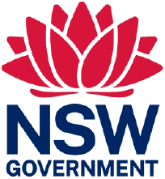
Public acknowledgement and disclaimer. This project is proudly funded by the NSW Government’s Pumped Hydro Recoverable Grants Program. The views expressed are not necessarily the views of the NSW Government. The NSW Government does not accept responsibility for any information or advice provided.

