

Lake Lyell Pumped Hydro

Pumped Hydro Energy Storage

Acknowledgement
EnergyAustralia and EDF power solutions Australia acknowledge that the site of the proposed Lake Lyell Pumped Hydro project is on the traditional Country of the Wiradjuri People. We recognise their continued connection to land, waterways and community, and we pay our respects to Elders past and present.
Contents
About the Environmental Impact Statement 2
Project overview and elements 2
What is pumped hydro energy storage? 2
How does it work? 3
What are the project elements? 4
Have your say on the Project 6
How we will use your feedback 6
Engage with us 6
Learn more 7
Get in touch 7

About the Environmental Impact Statement
We are progressing development of a pumped hydro energy storage project on land and waterways we own near Lithgow. An Environmental Impact Statement (EIS) is being prepared to meet NSW Planning Secretary’s Environmental Assessment Requirements. This includes information about pumped hydro energy storage, how it works and why it’s needed.

Project overview and elements
We present an overview of the project and its key elements here.

What is pumped hydro energy storage?
Pumped hydro is a proven and reliable form of energy storage, allowing energy to be stored for longer than most current battery technologies.
It uses two reservoirs of water — one up high and one down low to store energy and generate electricity. When power prices are low, energy is used to pump water from the lower reservoir to the upper reservoir. When energy is needed, the water from the upper reservoir is released back into the lower reservoir turning turbines which generate electricity. This electricity is sent to the grid for use in homes and business.
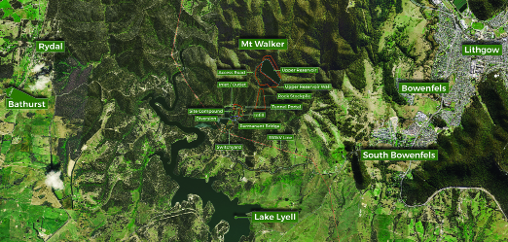

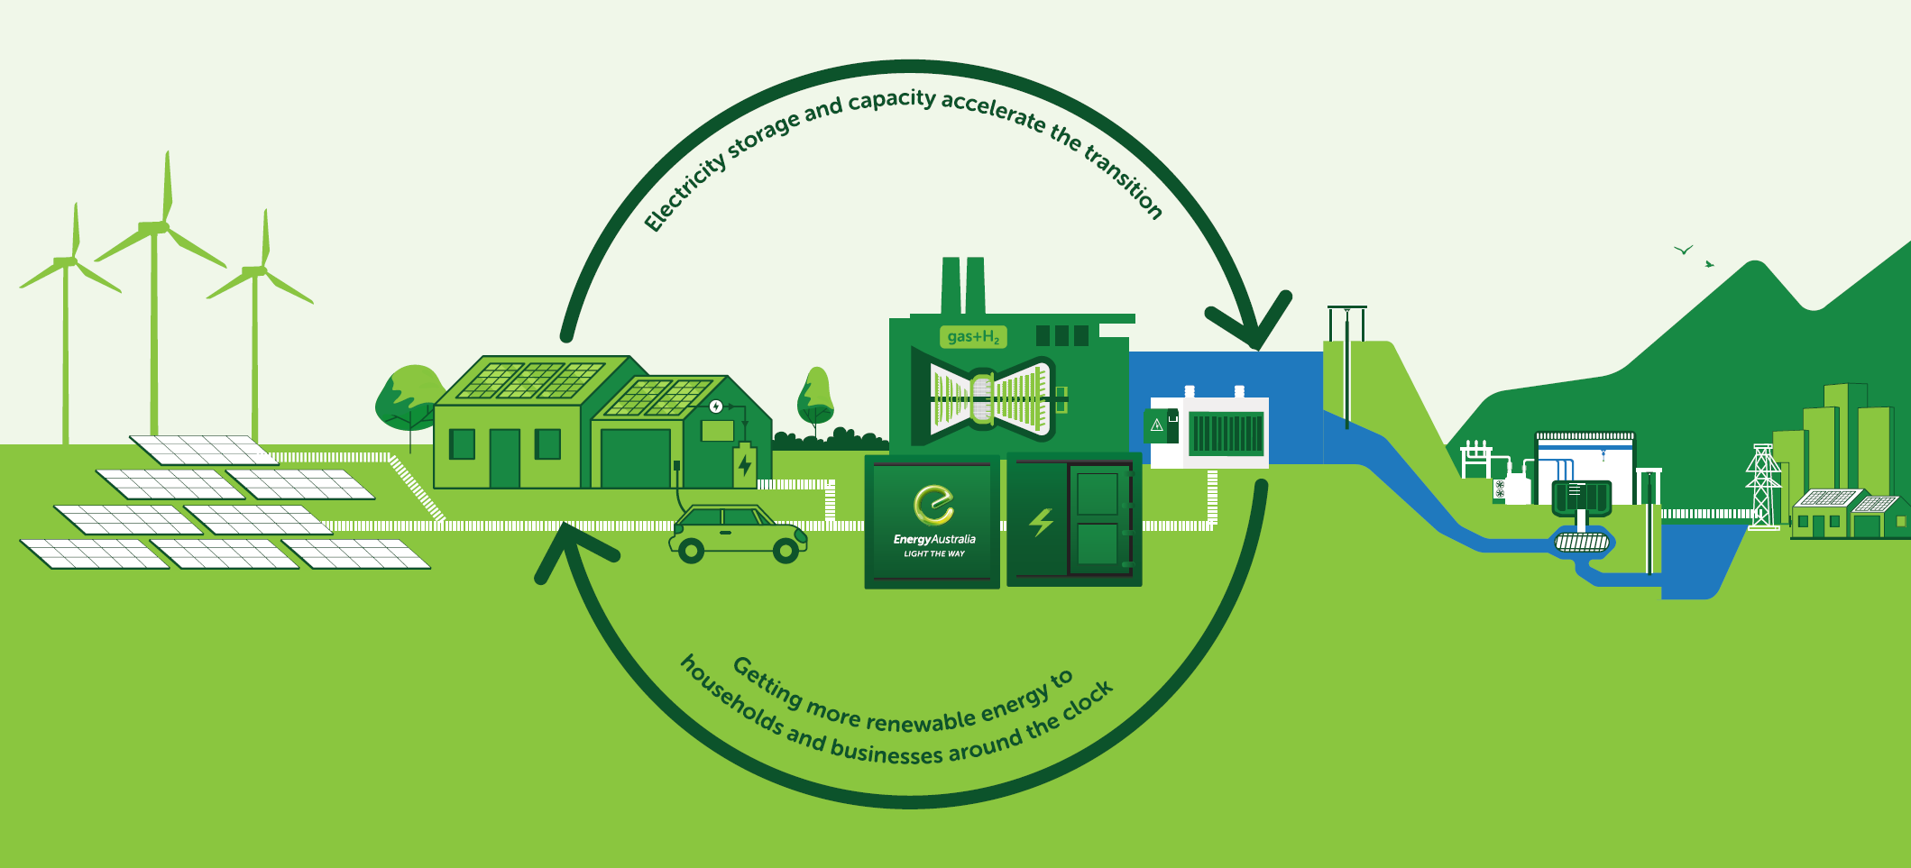
Pumped Hydro and the electricity grid.

How does it work?
 The Project will use water from Lake Lyell and see the development of a purpose-built reservoir behind the southern ridge of Mount Walker.
 The upper reservoir which stores the energy will connect through an underground waterway to a powerhouse with two pump turbine units approximately 170m below ground level, where the reversible generating units will store energy by pumping water to the upper reservoir, or generate energy by releasing water back down to Lake Lyell.
 Electricity will exit the powerhouse through buried cables to the 330kV switchyard on the edge of the lake connected to the existing 330kV transmission lines. The outlet from the powerhouse connects to the lower reservoir through the tail waterway which emerges into an inlet/outlet structure on the edge of Lake Lyell in Farmers Creek arm.
 During daily operating cycles Lake Lyell water level will fall and rise by approximately 2.5m over a typical 24 hrs as water is pumped from the lake to store energy and then is returned to the lake to deliver renewable and grid energy back into the grid.
 The project will generate up to 385 megawatts of electricity that can be switched on when energy is needed — and is sufficient to power 150,000 homes for up to 8 hours — offering more reliable and cleaner energy to support hundreds of thousands of homes and businesses in the local community, Central West region and across the state.
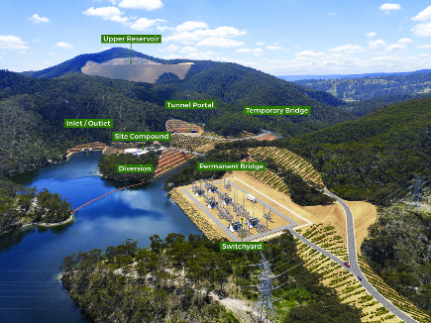
Lake Lyell Pumped Hydro project site view.

What are the project elements?
Although the principle of pumped hydro is relatively simple, there are many key elements to make it successful.
Project element | Description
Upper reservoir and dam | The upper reservoir will be a rockfill “gully dam” constructed behind the southeastern ridge of Mount Walker, over 250 metres above Lake Lyell. Its working storage volume will be 5.3 gigalitres which is the same as over 2100 Olympic swimming pools.
Lower reservoir (Lake Lyell) | Lake Lyell will be the project’s lower reservoir — so no new lower reservoir will need to be constructed. The lake was dammed in 1982 (Lilyvale Dam) and is filled by natural flow from the Coxs River and Farmers Creek. Its storage volume is 33.5 gigalitres. The project may run a full or part cycle over the day or week, and this may see the Lake Lyell water level change by differing amounts depending on the needs of the electricity network.
Upper reservoir inlet/outlet structure | The upper inlet/outlet structure will be located within the lowest point of the upper reservoir to deliver water up to the upper reservoir through the power waterways during pumping mode and release water to the power waterway during generation mode.
Lower intake/outtake structure | The lower inlet/outlet structure is within the lower reservoir (Lake Lyell) in Farmers Creek Arm. It draws water up to the upper reservoir through the power waterways during pumping mode and releases water from the power waterway during generation mode.
Power waterways | The power waterways connect the reservoirs. They will comprise:  - a single vertical inlet/outlet shaft which will extend down from the upper inlet/outlet structure. The shaft is approximately 7m in diameter and about 170 m deep  - an inclined single headrace tunnel that will extend downwards from the upper intake shaft. The tunnel is approximately 7 m in diameter and about 550 m long, before it splits into two tunnels leading to each pump turbine in the powerhouse  - two tunnels downstream of the powerhouse will rejoin into a single tailrace tunnel  - a single tailrace tunnel will connect the lower intake and the powerhouse. The lower waterway tunnel is approximately 7 m in diameter and about 500 m long  The power waterways will be lined with a combination of steel and concrete.
Underground powerhouse | Located in a deep underground cavern mid-way between the reservoirs, the powerhouse will contain the two reversible pump-turbines, control valves, generators, transformers and a variety of electrical equipment.
Access tunnels and portals | Access to the power waterways and the powerhouse will be attained via access tunnels and portals, which will include:  - the main access tunnel, approximately 7.5 m wide and 8.2 m tall, and about 600 m long  - the emergency, cable, and ventilation tunnel, approximately 7 m wide and 8.2 m tall, and about 500 m long  Each tunnel will open out to a portal/entrance at the surface, with an apron area of approximately 100 m x 50 m.
Surge shaft | One vertical underground surge shaft will be located downstream of the powerhouse and connected to the tailrace tunnel waterway and to the surface. The surge shaft will be around 11m diameter, and connect through to the surface.
Transmission connection | A High Voltage switchyard will contain the electrical equipment required to facilitate the connection between the project and the existing transmission network. A short connection will be constructed to connect the high voltage switchyard to the nearby existing Wallerawang to Sydney South 330 kV transmission line. An underground cable will connect the powerhouse main transformers and the switchyard.
Site access and ancillary features
Site access roads | It is proposed that the project area will be accessed via Sir Thomas Mitchell Drive, which will undergo upgrades to allow project-related vehicles safe access. Upgrades to the intersection of Sir Thomas Mitchell Drive and Magpie Hollow Road are also required. Upgrades to the intersection of Great Western Highway and Magpie Hollow Road are also required to allow transport of the largest of the oversized equipment to site.  Existing access roads within the project area will be upgraded as required and new ones will be constructed to allow access to key areas within the project area.
Bridges | A proposed permanent bridge will be established to cross the diverted path of Farmers Creek arm of Lake Lyell. This bridge will provide operational access to the upper reservoir and powerhouse.
Lake Lyell Diversion | The Farmers Creek arm of Lake Lyell will be diverted near the lower inlet/outlet structure. This will be undertaken to mitigate risks to project operation from flooding and the risks associated with sedimentation and to improve the overall constructability of the project. The lake diversion will be an open channel and designed to allow continued upstream and downstream passage of fish and aquatic fauna.  The part of the diverted lake area east of the lower inlet/outlet structure will be used for flood protection and access to the tunnel portals and housing spoil generated on-site. The part west of the lower inlet/outlet will be deepened and then rejoined with Lake Lyell.
Administration and utilities | The administration building will act as a control centre, staff centre and office. The building itself will be approximately 20 m x 15 m in size with a sealed carpark. The maintenance workshop/store will be located adjacent to the administration building.

Have your say on the Project
- Provide feedback during community consultations or public comment periods — your input helps shape aspects of the project as we progress
- Engage with project representatives or community committees to discuss concerns and suggestions

How we will use your feedback
Any feedback you provide before the Environmental Impact Statement is submitted will be recorded and, where appropriate, used to help refine the assessment and improve project outcomes.

Engage with us
There are many ways to have your say during the targeted community consultation running from 15 Oct to 30 Nov 2025 — online, in person, by phone or email. Find out more at:
lakelyellpumpedhydro.com.au


Consultation purposes only: This document is provided for community consultation purposes and the information it contains may be updated or revised in the final Environmental Impact Statement.

Learn more


Get in touch
E community@EnergyAustralia.com.au
P 1800 574 947
A EnergyAustralia Project HQ,
124 Main St, Lithgow
W lakelyellpumpedhydro.com.au

Proudly funded by

Public acknowledgement and disclaimer. This project is proudly funded by the NSW Government’s Pumped Hydro Recoverable Grants Program. The views expressed are not necessarily the views of the NSW Government. The NSW Government does not accept responsibility for any information or advice provided.

