

Lake Lyell Pumped Hydro

How community input has informed the Project to date

Acknowledgement
EnergyAustralia and EDF power solutions Australia acknowledge that the site of the proposed Lake Lyell Pumped Hydro project is on the traditional Country of the Wiradjuri People. We recognise their continued connection to land, waterways and community, and we pay our respects to Elders past and present.
Contents
Community consultation undertaken to date 2
Identified impacts and proposed mitigations 2
What is a consultation report? 2
How is a consultation report developed? 3
Who has been engaged and consulted? 3
What have been the activities and the involvement and influence? 3
Have your say on engagement 5
How we will use your feedback 5
Engage with us 5
Learn more 6
Get in touch 6

Community consultation undertaken to date
We are progressing development of a pumped hydro energy storage project on land and waterways we own near Lithgow.

Identified impacts and proposed mitigations
As part of our ongoing consultation with the community and stakeholders, we are sharing information on the potential impacts and proposed mitigations identified so far. Your feedback is important in shaping how these are assessed and addressed in the Environmental Impact Statement.
This summary outlines how — when presented with impacts, potential impacts and proposed mitigations — community involvement and input has influenced the project to date.
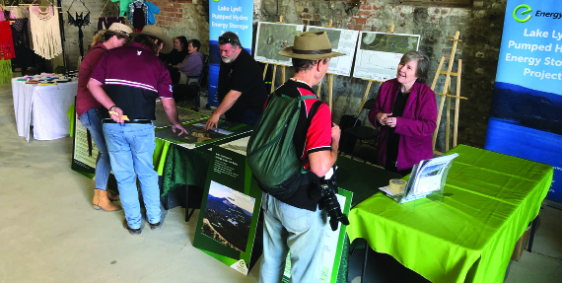
Community Engagement at Iron Fest in 2024.

What is a consultation report?
A Consultation Report is a formal document that outlines how community and stakeholder engagement was conducted during the preparation of an Environmental Impact Statement (EIS). It includes:
- who was consulted
- when and how engagement took place
- what feedback was received
- how that feedback influenced the project or EIS studies
The report demonstrates transparency, shows how community input was considered, and helps decision‑makers understand the level and outcomes of consultation.

How is a consultation report developed?
The Consultation Report is developed over the life of the project and documents how community and stakeholder engagement has informed the project design and development as well as all aspects of the Environmental Impact Statement. It involves:
- engagement planning by developing a Community and Stakeholder Engagement Plan early, outlining who to engage, when, how, and why
- program delivery where engagement activities are implemented across project phases to inform, consult, and involve stakeholders at key decision points
- record keeping where all engagement activities, feedback, and correspondence are documented systematically, ensuring transparency and traceability
- feedback integration where community input is analysed and used to help inform project design, impact assessments, mitigations, and communication strategies
- reporting when we provide a detailed summary of engagement activities, key issues raised, and how feedback help influence the project is compiled into the EIS Consultation Report
- submission — The Report is submitted with the EIS to evidence engagement and responsiveness to community concerns

Who has been engaged and consulted?
- Traditional Owners — engaged for cultural knowledge, heritage assessments, and ongoing oversight
- local council — Lithgow City Council involved in planning, design feedback, and regulatory matters
- government departments and regulators — relevant state and federal agencies consulted for environmental, planning, and compliance requirements
- community groups — various local and regional groups engaged to understand broader community perspectives
- residents of Lithgow and the region — general community input gathered through multiple engagement activities
- Community Consultative Committee (CCC) — a formal group representing diverse stakeholder interests providing regular feedback
- neighbours who are most impacted — property owners living near or likely to experience direct impacts, engaged individually to address specific concerns and mitigation

What have been the activities and the involvement and influence?
The engagement is consistent with the NSW Undertaking Engagement Guide: Guidance for State Significant Projects (DPHI, 2024), characterised by:
- early, inclusive planning
- tailored, transparent communications
- responsive to community feedback
- multiple formats — face-to-face, online, print, and video
- co-design of benefits and mitigations for those most impacted

 Consultation and engagement activities |  |  Community involvement and influences
Phase 1:  Preliminary Consultation (2021–2022) | - Early consultation with the Lithgow community via established forums (CCC, Lithgow City Council briefings)  - Initial announcement of potential pumped hydro at Lake Lyell (late-2021)  - First town hall (Dec 2021) attended by 150+ locals — concerns raised on recreation, property values, noise, visuals, jobs, and transparency  - Early engagement with the Concerned Lithgow Community Group | We planned early  We engaged early | Helped identify key interest groups and local concerns.
Phase 1:  Preliminary Consultation (2021–2022) |  | We identified matters of interest | Informed development of the Community & Stakeholder Engagement Plan.
Phase 1:  Preliminary Consultation (2021–2022) |  | We identified groups with interest | Consistent with NSW Engagement Guidelines: early, open, inclusive and transparent.
Phase 2:  Feasibility & EIS Scoping (2022–2023) | - Community engagement plan activated; first round of pop‑ups and newsletter to 5,198 households  - Establishment of the ‘Lithgow Light the Way’ Facebook page, regular updates and visual content  - Cultural awareness training with Mingaan Wiradjuri Aboriginal Corporation  - Engagement with 48 near neighbours (door knocks, one-on-ones, tailored renders)  - Design changes made to reduce visibility — upper reservoir moved behind Mount Walker ridge  - Submission of the Scoping Report (July 2023); Council briefings continued | You influenced design | Design influenced by community feedback.
Phase 2:  Feasibility & EIS Scoping (2022–2023) |  | We tailored engagement for neighbours | Neighbour engagement program established.
Phase 2:  Feasibility & EIS Scoping (2022–2023) |  | We increased access to project information | Improved transparency and access to information (website, social media, newsletters, Project HQ).  Feasibility phase aligned with NSW Engagement Guidelines — targeted, effective, proportionate.
Phase 3:  EIS Preparation & Impact Assessment (2023–2025) | - EIS studies commenced (Aug 2023); accessible info provided via newsletter and online  - Project HQ opened in Lithgow (Dec 2023) for in-person engagement  - Platypus study with community participation and UNSW experts  - Workshops held to co-design Community Benefit Sharing Program  - Cultural heritage assessments conducted with 21 Registered Aboriginal Parties — over 1,300 artefacts identified and returned to Country (March 2025)  - Pop-ups, webinars, and doorknocks continued across Lithgow, Wallerawang, Portland, and Rydal  - Neighbour Agreement Guide (formerly known as the Neighbour Benefit Guide) released (June 2024) and updated (April 2025)  - Fifth round of pop-ups (Feb-Mar 2025); feedback sought on workers’ accommodation  - Council engagement is ongoing (Nov 2024) | You helped us co-design  You participated in studies | Widespread involvement in technical and cultural studies.  Co-designed mitigation and benefit-sharing approaches for neighbours and community.
Phase 3:  EIS Preparation & Impact Assessment (2023–2025) |  | You accessed information in many ways | Improved project understanding through HQ, online, videos, newsletters, and Project HQ.
Phase 3:  EIS Preparation & Impact Assessment (2023–2025) |  | Eligible neighbours received draft agreements | Responsive, timely and inclusive engagement ahead of EIS exhibition.

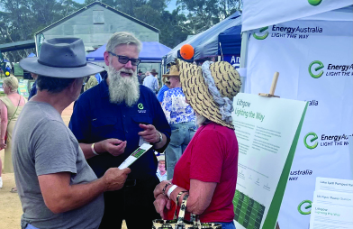
Community engagement at the Rydal Show in 2025.

Have your say on engagement
Everyone can continue to share their views and feedback as the project progresses. This includes:
- reviewing shared information on potential impacts and mitigation measures
- providing input on proposed plans and approaches
- participating in ongoing engagement activities such as meetings, pop-ups, and one-on-one discussions
- submitting feedback through online platforms or direct contact

How we will use your feedback
Any feedback you provide before the Environmental Impact Statement is submitted will be recorded and, where appropriate, used to help refine the assessment and improve project outcomes.

Engage with us
There are many ways to have your say during the targeted community consultation running from 15 Oct to 30 Nov 2025 — online, in person, by phone or email. Find out more at:
lakelyellpumpedhydro.com.au


Consultation purposes only: This document is provided for community consultation purposes and the information it contains may be updated or revised in the final Environmental Impact Statement.

Learn more


Get in touch
E community@EnergyAustralia.com.au
P 1800 574 947
A EnergyAustralia Project HQ,
124 Main St, Lithgow
W lakelyellpumpedhydro.com.au

Proudly funded by
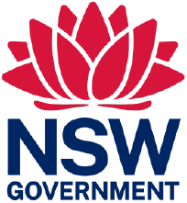
Public acknowledgement and disclaimer. This project is proudly funded by the NSW Government’s Pumped Hydro Recoverable Grants Program. The views expressed are not necessarily the views of the NSW Government. The NSW Government does not accept responsibility for any information or advice provided.

