

Lake Lyell Pumped Hydro

Economic impacts

Acknowledgement
EnergyAustralia and EDF power solutions Australia acknowledge that the site of the proposed Lake Lyell Pumped Hydro project is on the traditional Country of the Wiradjuri People. We recognise their continued connection to land, waterways and community, and we pay our respects to Elders past and present.
Contents
About the Environmental Impact Statement 2
What is an economic impact assessment? 2
How is an economic impact assessment undertaken? 3
How will impacts be managed? 3
Measuring the Economic Impact 4
Have your say on economic impact 4
How we will use your feedback 4
Engage with us 4
Learn more 5
Get in touch 5

About the Environmental Impact Statement
We are progressing development of a pumped hydro energy storage project on land and waterways we own near Lithgow. An Environmental Impact Statement (EIS) is being prepared to meet NSW Planning Secretary’s Environmental Assessment Requirements, including multiple technical studies such as the Economic Impact Assessment (EIA) summarised here.

What is an economic impact assessment?
An economic impact assessment identifies the economic impact of the Project on the regional (Lithgow LGA) and state (NSW) economy, during construction and operation, and decommissioning. It also outlines key investments and targets designed to stimulate economic activity.
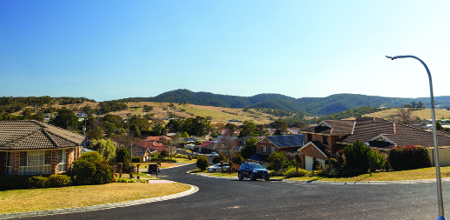
Annual direct and indirect output for the Lithgow regional economy is estimated at $400m.

How is an economic impact assessment undertaken?
This economic impact assessment has been undertaken using input-output (IO) analysis and examines direct and indirect economic activity. Economic activity has been identified in terms of four key indicators:
- gross regional output — the gross value of business turnover in a region
- value-added — the difference between the gross value of business turnover and the costs of the inputs of raw materials, components and services bought in to produce the gross regional output. These costs exclude wage costs
- income — the wages paid to employees including imputed wages for self-employed and business owners
- employment — the number of people employed (including self-employed, full-time, and part-time)

How will impacts be managed?
We are working with the community, business organisations, educational institutions and the NSW Government to help maximise the economic benefits — and minimise any adverse impacts. Our management measures include:
- employing local where we can
- using local supplies, where we can
- supporting local suppliers to innovate so they can supply
- implementing a significant local apprenticeship program
- providing training opportunities to grow renewable energy workforce
- investing in and working with business groups and regional development to maximise the economic benefits
- establishing a Shared Benefit Program to provide funding for local priorities like infrastructure, health, housing, and cultural heritage
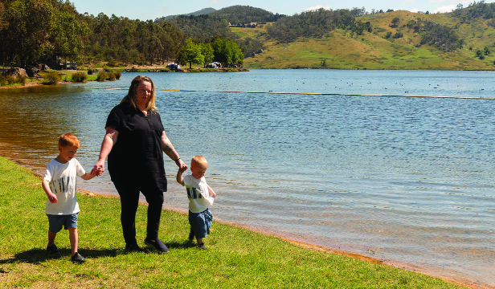

Measuring the Economic Impact
Economic impact* | Value ($)
Economic impact* | Regional economy (Lithgow) | State economy (NSW)
Project construction
Annual direct and indirect output | 400M | 566M
Annual direct and indirect value-added | 166M | 276M
Annual direct and indirect household income | 72M | 102M
Direct and indirect jobs | 658 | 912
Project operation
Annual direct and indirect output | 290M | 306M
Annual direct and indirect value-added | 237M | 246M
Annual direct and indirect household income | 4M | 8M
Direct and indirect jobs | 50 | 72
*Figures are estimates only

Have your say on economic impact
Your input helps to maximise projected economic benefits for local communities.
- suggest other ways we can manage the economic benefits of the Project
- suggest ways we can refine the Shared Benefits Program
- let us know if there’s something we’ve missed

How we will use your feedback
Any feedback you provide before the Environmental Impact Statement is submitted will be recorded and, where appropriate, used to help refine the assessment and improve project outcomes.

Engage with us
There are many ways to have your say during the targeted community consultation running from 15 Oct to 30 Nov 2025 — online, in person, by phone or email. Find out more at:
lakelyellpumpedhydro.com.au


Consultation purposes only: This document is provided for community consultation purposes and the information it contains may be updated or revised in the final Environmental Impact Statement.

Learn more


Get in touch
E community@EnergyAustralia.com.au
P 1800 574 947
A EnergyAustralia Project HQ,
124 Main St, Lithgow
W lakelyellpumpedhydro.com.au

Proudly funded by
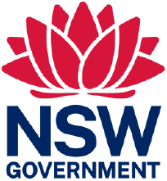
Public acknowledgement and disclaimer. This project is proudly funded by the NSW Government’s Pumped Hydro Recoverable Grants Program. The views expressed are not necessarily the views of the NSW Government. The NSW Government does not accept responsibility for any information or advice provided.

