

Lake Lyell Pumped Hydro

Aboriginal Cultural Heritage Assessment

Acknowledgement
EnergyAustralia and EDF power solutions Australia acknowledge that the site of the proposed Lake Lyell Pumped Hydro project is on the traditional Country of the Wiradjuri People. We recognise their continued connection to land, waterways and community, and we pay our respects to Elders past and present.
Contents
About the Environmental Impact Statement 1
What is an Aboriginal Cultural Heritage Assessment? 2
How is the Aboriginal Cultural Heritage Assessment undertaken? 2
What are the impacts and proposed mitigations? 2
Have your say on Aboriginal cultural heritage 3
How we will use your feedback 3
Engage with us 3
Learn more 4
Get in touch 4

About the Environmental Impact Statement
We are progressing development of a pumped hydro energy storage project on land and waterways we own near Lithgow. An Environmental Impact Statement (EIS) is being prepared to meet NSW Planning Secretary’s Environmental Assessment Requirements, including multiple technical studies such as the Aboriginal Cultural Heritage Assessment summarised here.
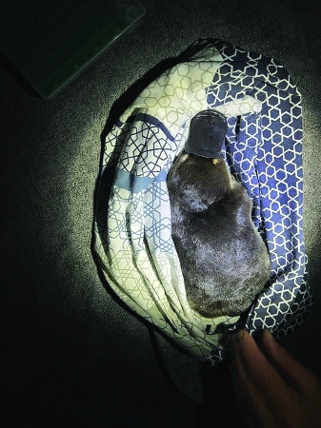
The platypuses found in Lake Lyell, such as this little one pictured here, have important cultural significance for local First Nations communities.

What is an Aboriginal Cultural Heritage Assessment?
It documents the assessment methods, results and the initiatives built into the Project design to avoid and minimise Aboriginal cultural heritage impacts.

How is the Aboriginal Cultural Heritage Assessment undertaken?
This assessment included an archaeological field survey and shallow hand digging to document the Aboriginal objects, sites and places within the Project area, and understand their significance within the regional context.

What are the impacts and proposed mitigations?
There are several locations with tangible archaeological materials that show past use of the area by First Nations people within the Project construction envelope. These locations will be directly impacted by construction. There are also culturally‑important places including the peak of Mount Walker and the Platypus Dreaming story (which is associated with Coxs River and surrounding tributaries) that will also be impacted.
Impacts will be or have been reduced through designing the Project to partially or entirely avoid certain locations and implementing measures listed in the Project’s Aboriginal Cultural Heritage Management Plan.
Impacts to the culturally important places have been or will be reduced through Project design.
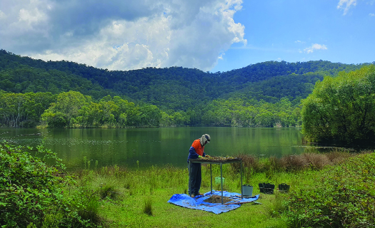
Site investigations being undertaken for the Aboriginal Cultural Heritage Assessment in 2024.

Have your say on Aboriginal cultural heritage
Your input can inform effective and locally relevant protections:
- suggest ideas or propose alternative management and mitigation measures that you think could better protect Aboriginal cultural heritage
- provide feedback on proposed mitigation plans during community consultations or public comment periods
- engage with project representatives or community committees to discuss concerns and suggestions

How we will use your feedback
Any feedback you provide before the Environmental Impact Statement is submitted will be recorded and, where appropriate, used to help refine the assessment and improve project outcomes.

Engage with us
There are many ways to have your say during the targeted community consultation running from 15 Oct to 30 Nov 2025 — online, in person, by phone or email. Find out more at:
lakelyellpumpedhydro.com.au


Consultation purposes only: This document is provided for community consultation purposes and the information it contains may be updated or revised in the final Environmental Impact Statement.

Learn more


Get in touch
E community@EnergyAustralia.com.au
P 1800 574 947
A EnergyAustralia Project HQ,
124 Main St, Lithgow
W lakelyellpumpedhydro.com.au

Proudly funded by
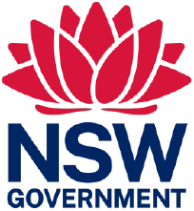
Public acknowledgement and disclaimer. This project is proudly funded by the NSW Government’s Pumped Hydro Recoverable Grants Program. The views expressed are not necessarily the views of the NSW Government. The NSW Government does not accept responsibility for any information or advice provided.

