

Lake Lyell Pumped Hydro

Biodiversity

Acknowledgement
EnergyAustralia and EDF power solutions Australia acknowledge that the site of the proposed Lake Lyell Pumped Hydro project is on the traditional Country of the Wiradjuri People. We recognise their continued connection to land, waterways and community, and we pay our respects to Elders past and present.
Contents
About the Environmental Impact Statement 2
What is a biodiversity impact assessment? 2
How is biodiversity impact assessment undertaken? 2
What are the impacts? 4
What are the proposed mitigations? 4
Have your say on biodiversity 4
How we will use your feedback 4
Engage with us 4
Learn more 5
Get in touch 5

About the Environmental Impact Statement
We are progressing development of a pumped hydro energy storage project on land and waterways we own near Lithgow. An Environmental Impact Statement (EIS) is being prepared to meet NSW Planning Secretary’s Environmental Assessment Requirements, including multiple technical studies such as the biodiversity impact assessment summarised here.

What is a biodiversity impact assessment?
A biodiversity impact assessment identifies potential impacts to terrestrial and aquatic (land-based and water-based) plants and animals within the Project footprint. It also proposes initiatives built into the Project design to avoid and minimise impacts, and other proposed mitigation and management measures such as offset requirements to address any unavoidable residual impacts. The assessment follows the NSW Biodiversity Assessment Method, which ensures a consistent approach to assessing and managing biodiversity.

How is biodiversity impact assessment undertaken?
A biodiversity study involves scientists, ecologists, and other experts surveying plants and animals across seasons — conducting fieldwork, species counts, and habitat assessments to understand the local environment and how it may be impacted. This study commenced in 2023 and finished earlier this year.
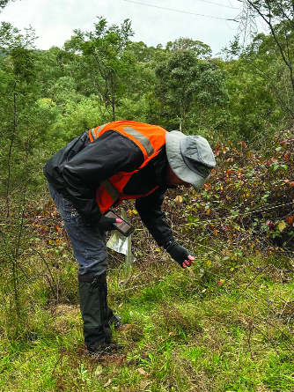
Ecologists undertook extensive investigation in and around Lake Lyell and Mount Walker.
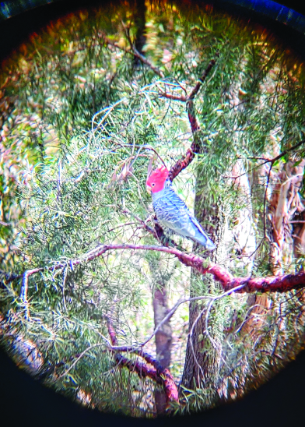
The Gang-gang Cockatoo is found within and around the Project area.

What are the impacts?
Terrestrial flora and fauna — The Project will require clearing of some native vegetation, which will result in the loss of habitat for threatened species such as the Powerful Owl and Gang‑gang Cockatoo. This includes removal of hollow-bearing trees, potential breeding areas and wildlife movement corridors.
Aquatic flora and fauna — No threatened aquatic species have been detected in the Project area. However, there are sensitive fish habitats and a platypus population. The Project may have an impact to these through habitat loss, water quality impacts, and movement disruption.

What are the proposed mitigations?
Project design — Has been shaped by the measures suggested in the biodiversity studies. These measures include avoiding sensitive areas and setting back work from Marrangaroo National Park and Farmers Creek. Other measures include using existing infrastructure, such as using Lake Lyell to act as the lower reservoir. This negates the need to build a new lower reservoir, which in turn minimises further construction impacts.
The Project design also includes a lake diversion at the mouth of Farmers Creek to create a passage for fish and platypus to connect Farmers Creek and the lake and help avoid direct impacts on local platypus and fish populations.
As design progresses, it is anticipated that refining the disturbance footprint will continue.
Platypus Management Plan — Is proposed to be developed to help protect the platypus, will outline measures such as avoiding certain construction activities during the nesting season, inspecting for and relocating platypuses if needed, rehabilitating disturbed areas, and managing water quality with silt curtains. Adaptive measures, developed with experts and First Nations representatives, will be considered if platypus health declines.
Flora and Fauna Management Plan — Is proposed to be developed as part of the Construction Environmental Management Plan. This will outline measures to help reduce impacts on aquatic flora and fauna, including inspections and monitoring, rehabilitation requirements and sedimentation management.
Biodiversity offsets — Establishing biodiversity offsets through stewardship sites and credit purchases.

Have your say on biodiversity
Your input helps shape effective and locally relevant biodiversity protections:
- suggest ideas or propose alternative mitigation measures that you think could better help protect local biodiversity
- provide feedback on proposed mitigation plans identified here, during community consultations or public comment periods
- nominate or volunteer to participate in offset programs, such as stewardship sites or local habitat restoration projects
- engage with project representatives or community committees to discuss concerns and suggestions

How we will use your feedback
Any feedback you provide before the Environmental Impact Statement is submitted will be recorded and, where appropriate, used to help refine the assessment and improve project outcomes.

Engage with us
There are many ways to have your say during the targeted community consultation running from 15 Oct to 30 Nov 2025 — online, in person, by phone or email. Find out more at:
lakelyellpumpedhydro.com.au


Consultation purposes only: This document is provided for community consultation purposes and the information it contains may be updated or revised in the final Environmental Impact Statement.

Learn more


Get in touch
E community@EnergyAustralia.com.au
P 1800 574 947
A EnergyAustralia Project HQ,
124 Main St, Lithgow
W lakelyellpumpedhydro.com.au

Proudly funded by
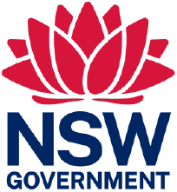
Public acknowledgement and disclaimer. This project is proudly funded by the NSW Government’s Pumped Hydro Recoverable Grants Program. The views expressed are not necessarily the views of the NSW Government. The NSW Government does not accept responsibility for any information or advice provided.

