

Lake Lyell Pumped Hydro

Construction methodology, air quality, noise and vibration

Acknowledgement
EnergyAustralia and EDF power solutions Australia acknowledge that the site of the proposed Lake Lyell Pumped Hydro project is on the traditional Country of the Wiradjuri People. We recognise their continued connection to land, waterways and community, and we pay our respects to Elders past and present.
Contents
About the Environmental Impact Statement 2
What is the proposed construction methodology? 2
How are air quality, noise and vibration impacts assessed? 2
What are the identified impacts and proposed mitigations 3
Have your say on construction methodology and air quality, noise and vibration impacts 4
How we will use your feedback 4
Engage with us 4
Learn more 5
Get in touch 5

About the Environmental Impact Statement
We are progressing development of a pumped hydro energy storage project on land and waterways we own near Lithgow. An Environmental Impact Statement (EIS) is being prepared to meet the NSW Planning Secretary’s Environmental Assessment Requirements. This EIS includes multiple technical studies, such as the Air Quality Impact Assessment; Green House Gases Impact Assessment; the Noise and Vibration Impact Assessment; and descriptions about the construction methodology, all of which are summarised here.

What is the proposed construction methodology?
The EIS will include a Project Description which will provide a detailed description of the project, particularly with regard to how it is planned to be built and operated including detailed maps and plans.
For the Lake Lyell Pumped Hydro Project, we’ve developed our approach using international best practice. And from day one, our goal has been to avoid and minimise disruption wherever we can. That starts with planning — and already, it’s shaping how we build. We’ve relocated the upper reservoir to reduce how visible the infrastructure is from nearby homes and lookouts. We’re using the proposed switchyard for construction laydown to limit how much land we need to disturb. And we’ve designed the powerhouse and tunnels to go underground — helping to reduce noise, protect local wildlife, and preserve the landscape.
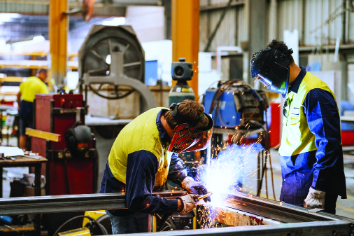

How are air quality, noise and vibration impacts assessed?
The Air Quality and Green House Gases Assessments evaluated the Project’s potential air quality impacts through emissions from construction activities and when the project is operational. To do this, the Assessments compared existing local air quality, meteorological conditions and greenhouse gas emissions and estimated how local conditions would be impacted by the Project’s predicted emissions.
The Air Quality Assessment was based on the NSW EPA’s Approved Methods for Modelling.

The Greenhouse Gases Assessment was developed inline with the Greenhouse Gas Protocol — the internationally recognised accounting framework for measuring and reporting greenhouse gas emissions.
The Noise and Vibration Impact Assessment evaluated potential noise and vibration effects on the environment and surrounding communities caused by construction activities and noise and vibrations from pumps or generators when the Project is in operations.
A selection of representative residential, commercial, industrial, and recreational properties in the Project area were used as assessment locations for these studies.

What are the identified impacts and proposed mitigations
Excavation work, especially with heavy machinery, can be noisy and stir up dust as we move soil and rock.
You’ll also see and hear activity in the area — trucks moving along the mountain, new access roads being built, and work underway at the site of the upper reservoir.
We know that protecting air quality is important, and of course the Project is required to stay within dust limits set by the EPA.
There will be some construction noise that is likely to affect certain areas around the Project — but we’re planning ahead to manage that.
We’re committed to minimising dust, emissions, noise and vibration impacts — using the right equipment, managing work hours, and putting controls in place to reduce the impact on the community and the environment.
In addition to these measures, the Project has implemented Neighbour Agreements that offers support for eligible neighbours. Minimising, managing and mitigating impacts is our ongoing commitment.
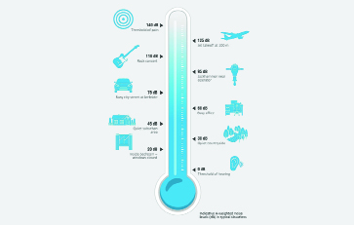

Have your say on construction methodology and air quality, noise and vibration impacts
- Provide feedback on proposed mitigation plans
- Eligible neighbours can contact us to talk through their neighbour agreement
- Engage with project representatives or community committees to discuss concerns and suggestions

How we will use your feedback
Any feedback you provide before the Environmental Impact Statement is submitted will be recorded and, where appropriate, used to help refine the assessment and improve project outcomes.

Engage with us
There are many ways to have your say during the targeted community consultation running until 30 Nov 2025 — online, in person, by phone or email. Find out more at:
lakelyellpumpedhydro.com.au


Consultation purposes only: This document is provided for community consultation purposes and the information it contains may be updated or revised in the final Environmental Impact Statement.

Learn more


Get in touch
E community@EnergyAustralia.com.au
P 1800 574 947
A EnergyAustralia Project HQ,
124 Main St, Lithgow
W lakelyellpumpedhydro.com.au

Proudly funded by
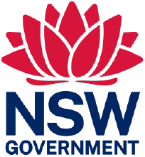
Public acknowledgement and disclaimer. This project is proudly funded by the NSW Government’s Pumped Hydro Recoverable Grants Program. The views expressed are not necessarily the views of the NSW Government. The NSW Government does not accept responsibility for any information or advice provided.

