
 What we have heard  HAVE YOUR SAY  GET THE FACTS

Community Newsletter
Issue 11 | OCTOBER 2025 — SPECIAL EDITION
Contents
Have Your Say on the Lake Lyell Pumped Hydro Project 2
How to have your say 3
Sharing what we have heard 3
About the Environmental Impact Statement 3
Plot your ideas 4
Opportunities for Lithgow 4
Recreation and water access 5
Getting the facts 6
Engage with us 7
We’re here to help 7

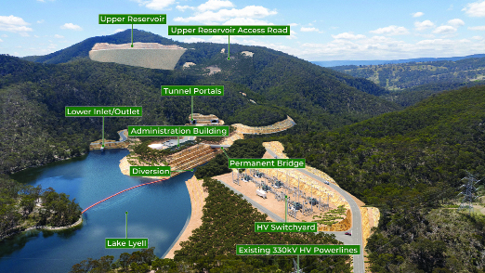
Artist’s impression of the proposed Lake Lyell Pumped Hydro Project.

Have Your Say on the Lake Lyell Pumped Hydro Project
For over 70 years, the Lithgow region has helped power homes and industries across NSW and Australia. As we move into a new energy future, we’re committed to making sure Lithgow remains at the heart of energy generation — and continues to benefit from it.
This special edition newsletter outlines how you can learn more and have your say on the Lake Lyell Pumped Hydro Project before the EIS is finalised. Have your say is open to 30 November 2025.
We know this transition brings both challenges and opportunities. That’s why we’ve been talking with the community since 2021 — and why listening has been central to everything we do.
Through surveys, drop-in sessions, meetings and conversations with neighbours, Traditional Owners, Council, and community groups, we’ve heard what matters to you.
Your input has already led to real changes: moving the upper reservoir to reduce visual impact, proposing a new location for worker accommodation, and co-designing a Neighbour Agreement Guide. We’ve also boosted access to project updates with newsletters, social media, and a local Project HQ.
All of this will be outlined in a Consultation Report, as part of the EIS. It will show who we’ve spoken to, what we heard, and how that feedback has helped shape the project.
Now, we’re inviting you to continue the conversation.
Take the time to review what we’re sharing, see how impacts are being addressed — from environment to roads to cultural heritage to recreation access — and let us know what you think.
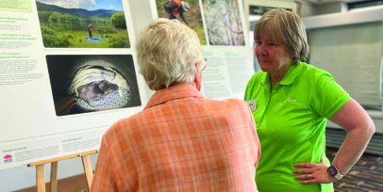

How to have your say
The Lithgow community are invited to have their say on the Lake Lyell Pumped Hydro project before the EIS is finalised in-person or online at www.lakelyellpumpedhydro.com.au
Speak directly with the project team and technical experts about key Environmental Impact Statement (EIS) topics at local community events, drop into your local library, or stop by Project HQ — now with extended hours each Saturday. You can also explore the ‘Have Your Say’ section on our website to watch videos, read information sheets, and share your feedback.

Sharing what we have heard
We’ve been having conversations about pumped hydro with the community since 2021, and it’s important to reflect what we’ve heard and show how your input has helped shape the project.
To do this, we’ve put together easy-to-read summaries for each of the key EIS topics, so you can see the feedback we’ve received and how it’s been considered in our planning.
Find out what we have heard as well as insights from the EIS on key topics such as:
 What we have heard to date
 Economic impacts
 Recreation and water
 Biodiversity
 Workers accommodation
 Traffic
 Cultural heritage
 Construction — air quality, dust and noise
 Viewpoints and visual impacts

About the Environmental Impact Statement
We are progressing development of a pumped hydro energy storage project on land and waterways we own near Lithgow. An Environmental Impact Statement (EIS) is being prepared to meet NSW Planning Secretary’s Environmental Assessment Requirements, including multiple technical studies.
EnergyAustralia and EDF power solutions Australia acknowledge that the site of the proposed Lake Lyell Pumped Hydro project is on the traditional Country of the Wiradjuri People. We recognise their continued connection to land, waterways and community and we pay respects to Elders past and present.

Economic impact* | Value ($)
Economic impact* | Regional economy (Lithgow) | State economy (NSW)
Project construction
Annual direct and indirect output | 400M | 566M
Annual direct and indirect value-added | 166M | 276M
Annual direct and indirect household income | 72M | 102M
Direct and indirect jobs | 658 | 912
Project operation
Annual direct and indirect output | 290M | 306M
Annual direct and indirect value-added | 237M | 246M
Annual direct and indirect household income | 4M | 8M
Direct and indirect jobs | 50 | 72
*Figures are estimates only.

Plot your ideas
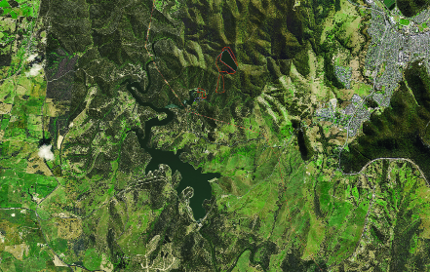

Opportunities for Lithgow
The Project presents real opportunities — for the economy, businesses and the broader region.
A key part of the EIS is a technical study called the Economic Impact Assessment which identifies the economic impact of the Project on the regional (Lithgow LGA) and state (NSW) economy, during construction and operation as highlighted in the table.
During construction the estimated annual injection to the regional economy is $400 million. We have seen the impact of this kind of stimulus firsthand on local businesses, and we want to help maximise these economic benefits.
We are working with the community, business organisations, education institutions and the NSW Government to:
- employ local where we can
- use local supplies
- support local suppliers to innovate so they can supply
- implement a significant local apprenticeship program
- provide training opportunities to grow a local renewable energy workforce
- invest in and work with business groups and regional development to maximise the economic benefits

Recreation and water access
Since 2021, we’ve been collecting community ideas for how residents and visitors can continue enjoying Lake Lyell while the pumped hydro project is under construction and operating.
We’re planning new infrastructure and recreational features to ensure safe, ongoing access to and around the water. We need your input to make this work.
Community members have already proposed floating docks, extended boat ramps, boardwalks, art installations, mountain biking trails, bird observation areas, education centers, variable signage, and more.
Share your ideas:
- visit our map at Project HQ (124 Main Street, Lithgow)
- talk to us at community events
 Water access and recreation
 Community and social spaces
 Trails and viewing areas
 Safety features
 Adventure or overnight use
 Nature and environment
 Education and identity

Getting the facts
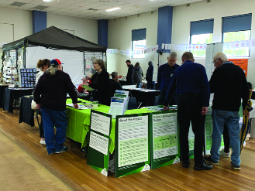
We have heard a wide range of comments and received hundreds of questions since beginning engagement on the project in 2021, here are some of the key responses.
Comment: “Can we still use Lake Lyell?”
Answer: Yes. You will still be able to use Lake Lyell, built to supply water to the Mt Piper Power Station, for recreation including swimming, fishing, boating, kayaking and waterskiing. During daily operating cycles, the water level will rise and fall by about 30 cm every half hour or 2.5 metres over 8 hours as water is pumped to and from the upper reservoir to store and generate energy.

Comment: “Why don’t you just build more grid-scale batteries?”
Answer: Different technologies play different roles in our energy market. Batteries operate over shorter periods. Pumped hydro operates over longer periods and are often referred to as long duration storage.
Batteries have a life span of between 15 to 20 years, while pumped hydro has a lifespan of 80 to 100 years. This diversity in asset classes provides greater long-term supply and stability in the system as the various technologies can complement each other to underpin the lowest possible long term power prices to consumers.

Comment: “If I was an eligible neighbour, how do you support me?”
Answer: Eligible neighbours can participate in the voluntary Neighbour Agreement program and receive a Stage 1 agreement to acknowledge wellbeing impacts as well as the investment of your time to engage. Also on offer is the Stage 2 agreement specific to impacts you are likely to experience, and which provides tailored compensation for your property or personal circumstances. This includes financial support as well as practical property alternations or business viability support.

Engage with us
We are out and about and available to answer your questions and receive your feedback through to 30 November 2025, and there are lots of ways to get involved — online, in person, over the phone, or by email.
24/7
Online lakelyellpumpedhydro.com.au
Weekends
Various community events
Weekdays
Project HQ 9am to 5pm
Saturdays
Project HQ 10am to 2pm

We’re here to help
If you have a question, please don’t hesitate to contact us.
 community@EnergyAustralia.com.au
 1800 574 947
 EnergyAustralia Project HQ,
124 Main Street, Lithgow

Lake Lyell Pumped Hydro

